Ministry of Education, Heritage &Arts 2021 LITERACY WORKSHEET 3
YEAR 1

Lesson: Literacy | Class: 1 | Date:
Objective of the activity:
- Children will be able to circle the picture which correctly represents the word in each row.

- Circle the picture that best represents the word on the left side of each row.

box | 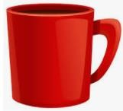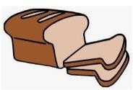
duck | 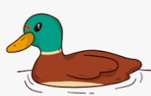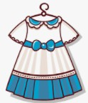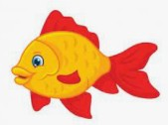
horse | 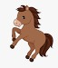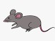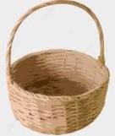
mango | 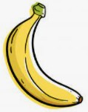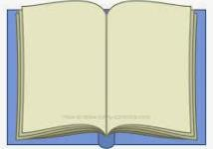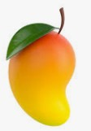
shoe | 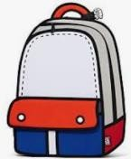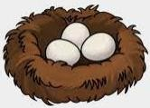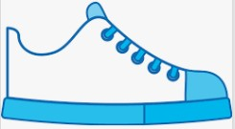
Learn these words: box
duck
horse
mango
shoe

Instructions to Parents/Guardians

- Find a quiet place to sit with your child and complete the worksheet.
- Make sure that your child’s working space is free and not cluttered while she/he circles the correct picture.
- Your patience and understanding are greatly needed when completing the worksheet with your child.
- Read and explain the instructions to your child as you go along,.
- Repeat the instructions in your mother-tongue if your child does not understand.
- Remember to praise your child when she/he attempts the questions.

For students with Vision Impairment: | - Provide the child with the real objects.  - Name the object.  - Put three of the objects in front of the child and ask him/her to feel each of them before pointing to the correct object that represents the name. Parent can circle the right picture or braille the answer in the answer sheet.  - Children with low vision will be able to work independently on the same activity if it is printed on a big paper or re- written using big font size.
For students with Hearing Impairment: | - Talk about the pictures with your child. Deaf children will require sign language.  - Use vernacular if the child has difficulty identifying the picture in the English version. Provide clue.  - To help blind students, use white ink or nail polish around on the border of the picture so that the child is able to feel the shape of the picture. Ensure that white ink or nail polish is thick enough for children to feel. Parent to read the word aloud and child to pick the correct picture for the word.

